Visitors Testing Guidance Pack
Lateral Flow Devices (LFD) in care homes

Contents

Overview 2
What to expect with LFD testing in care homes 3
Do I have to be tested in order for me to visit my relative? 3
Preparing for your visit 4
On the day of your visit 4
Key steps during the test 5
During your visit 8
What can you do during your visit? 8
What are you not allowed to do during your visit? 8
How to put on PPE instructions 9
How to safely remove PPE instructions 10
How to register your test kit 11
Details needed for the online registration form 11

Self-swabbing instructions 12
8 December 2020
1

Visiting is a central part of care home life. It is crucially important for maintaining health and wellbeing and quality of life for residents. Visiting is also vital for family and friends to maintain contact and life-long relationships with their loved ones and contribute to their support and care (often as essential carers).
To support meaningful visiting, the Department of Health and Social Care is rolling out new rapid tests to care homes to test visitors. This will enable care homes to offer regular testing of visitors, to support more meaningful visits with loved ones.
While testing visitors can reduce the risk associated with visiting, it does not completely remove the risk of infection. When used alongside robust Infection Prevention
and Control (IPC) measures such as Personal Protective Equipment (PPE), it can support care homes to safely maintain a balance between infection control and the vital benefits of visiting to the health and wellbeing of residents.
Friends and relatives have a very important role and responsibility to help care homes to keep their loved ones safe. Please think of yourself as part of a team with the care home staff. By carefully following the steps described in this document and requirements laid out by the home, you will be playing your part in helping to protect not just your loved one, but all the people with whom they share their home, from the risk of infection.

Care homes will contact relatives and friends of residents to let them know when testing for visitors will be made available. You will be asked to complete a test every time you visit.
Please read this Visitors Guidance Pack carefully so that you know what to expect for your visit, as well as the precautions the home will ask that you take to keep your loved ones and all their residents and staff safe.
In the event of an outbreak in a care home, please note that apart from in exceptional circumstances, visits will not be allowed.

Do I have to be tested in order for me to visit my relative?
Testing is really important to help us to identify people who might be carrying Coronavirus but not showing symptoms. Testing may not identify everyone that is currently infectious, but alongside wearing PPE and following other infection prevent and control measures, testing helps keep the care home and your loved ones safe.
If you do not want to take a test or testing is not available on the day you visit, please do discuss this with our care home manager. Without testing, indoor visits may still be possible in Tier 1 areas provided they are limited to two people, with social distancing, no physical contact, full PPE and good hand hygiene observed at all times. Testing is by far the preferable option and should be used where possible
In all tiers outdoors visits and those where the resident and visitor are separated by a substantial screen can be made available without the need for testing.
The home will decide how best to manage visits based on clinical guidance on infection control and testing and will talk through possible options for visits.
Please be aware that organised visits are at the home’s discretion, and based on an individualised risk assessment, the care home manager may advise that it might not be possible to facilitate visits with you at this time.

To keep your loved one and the care home safe, we ask that you please follow the below guidelines:

Preparing for your visit

Stay home if you’re feeling unwell, including if you have a fever, a cough or a change in your sense of taste and smell.
Follow national guidance outside of your visit, including limiting your contact with other people and wearing a face covering in indoor settings where social distancing may be difficult, and where you will come into contact with people you do not normally meet.
Observe social distancing with anyone outside of your household or bubble and wash your hands regularly.

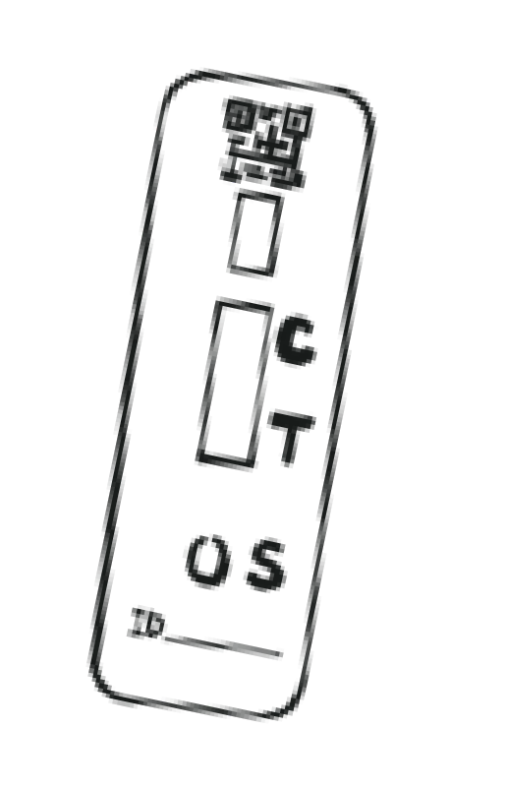
You’ll be asked to take a test using a new technology called a

On the day of your visit
Lateral Flow Device (LFD) test. You’ll be tested before visiting your relative to check if coronavirus can be detected. Lateral flow testing is not a fool proof solution: it should be taken in addition to Personal Protective Equipment (PPE) and other Infection Prevention and Control (IPC) measures and must not be seen as a way of relaxing their use.
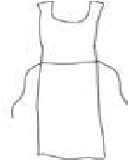
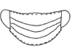
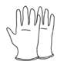
For this, the home will ask you to do a throat and nose swab every time you visit and then will let you know your result in 30 minutes. The home will ask you to complete the swabbing yourself, supervised by a
member of staff. A swab is a small piece of soft, absorbent material on a plastic stick that is used to take a sample from your nose and throat.
The test is very straightforward and you’ll be supported throughout the process by a trained member of staff from the care home.

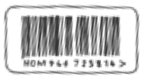
Key steps during the test

1 When you first enter the care home:
- A staff member will provide Personal Protective Equipment (PPE) and support you with putting it on. This will include:

Gloves Mask Apron

See page 9 for more details on how to properly put on PPE.

- A staff member will take your temperature.

- You’ll be asked to sign a consent form that you agree to taking the test and sharing your result. The home may also ask that you share personal details including your date of birth, ethnicity, and contact details to support you with registering your test result. Registering your test result is important because it links you to your individual test kit.
- A staff member will check you in for your visit.

- A staff member will provide you with 4 copies of your test kit barcode. One copy is for a staff member to put on your lateral flow device, and the others are copies. These barcodes will track your individual test to you. Make sure to keep these copies with you throughout the rest of the testing process.

5

Taking your test:
2
3
- After you check in for your test, a member of staff will direct you to move to the testing area.
- You will hand one copy of your barcode to the member of staff supporting your testing process.
- A member of staff will hand you a packaged swab.
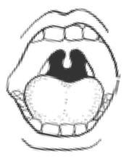
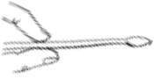
10
secs
10
secs

- You will then need to take your own throat and nose swab, supervised by a member of staff. They will walk you through how to swab yourself which will only take about 30 seconds to do. See page 12 for more details on how to swab yourself.
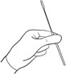
- Once you have handed over the swab, you will be asked to wait in a designated area until your result is ready. This will take approximately 30 minutes.

Receiving your result:
- After 30 minutes, a staff member will tell you your result.

- Once you have received your result, you will need to register your test kit online with your own mobile device or a device provided to you if you do not have a mobile. If you are not able to register your own result, a member of staff can help you but they’ll need to take down your personal details. See page 11 for more details on how to register your test result.

What does your result mean?
Care home staff will help you process your test and give you a result within 30 minutes. The result will affect whether you can complete your visit in the following ways:

Positive result

Positive
you will not be able to visit. You will have to take a second test, which is a confirmatory Polymerise Chain Reaction (PCR) test
that the home will provide for you. You will have to take the test and
register it on site, then go home immediately and self-isolate until you receive your result. NHS Test & Trace will text, e-mail, or call you with your result in around 72 hours. If you test positive, NHS Test & Trace may contact you to ask you for your close contacts.

Invalid or void result
?
Invalid or Void
The home will ask that you take another LFD test. If the retest comes back as invalid, the home will recommend that you do not complete the visit unless both you and the home are in Tier 1, and other IPC measures, including social distancing and PPE, are followed.

Negative result

Negative
Your visit will be able to go ahead, as long as you comply with all other IPC measures (see below). It is possible that you may still have
COVID-19, so the home will need to make sure you wear PPE at all times and ensure that the visit takes place in a safe way. If you have any questions about this, please ask the care home manager and staff for advice.

It is important to recognise that a negative test will provide us with some assurance that you are not carrying the virus. However, the test is not a complete guarantee. To keep your loved one and the care home safe, we ask that you please follow the guidelines below during your visit.
Inside the care home, wear your face mask and any other PPE that you were asked to wear by a member of staff. Please continue to follow their visiting policy.

What can you do during your visit?

Holding hands and personal contact are allowed if you have a negative test result and PPE, but visitors should minimise contact as much as possible to reduce the risk of transmission.

Bringing along food to the resident is also allowed.

During your visit, please make sure:

You keep your PPE on at all times

You only go to the part of the care home that is permitted for your visit

You follow carefully any guidance and instructions provided by care home staff

1
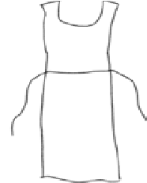
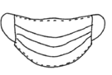
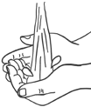
Perform hand hygiene using soap and water or alcohol hand gel.

2
Put on a plastic apron and tie it at the waist.

3
Put on a surgical face mask, positioning upper straps on the crown of your head, lower strap at nape of neck. With both hands, mould the metal strap over the bridge of your nose.

4
Put on plastic gloves.

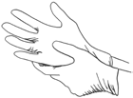
You are now ready to enter the care home testing area.

1
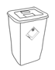
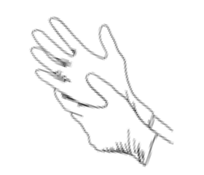
Remove gloves; grasp the outside of the cuff of the first glove and peel off, holding the glove in the gloved hand, insert the finger underneath and peel off second glove.

2

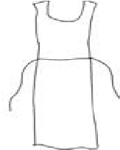
Snap or unfasten apron ties at the neck and let the apron fold down on itself. Break ties at waist and fold apron in on itself – do not touch the outside – this will be contaminated. Discard apron.

3

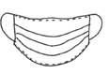
Remove surgical mask carefully, and put into clinical waste.

4

Perform hand hygiene using soap and water or alcohol hand gel or rub.

Once your result is determined, your test kit needs to be registered online using a self-test registration form. You can complete this form using your own mobile phone or a mobile device provided by the home. Once the form is complete, you will follow the appropriate guidance based on your result as set out above on page 7.
If you cannot complete this form yourself, a member of staff can complete it for you. They will ask you to provide some personal details required in the form.

Details needed for the online registration form:
  - Full name

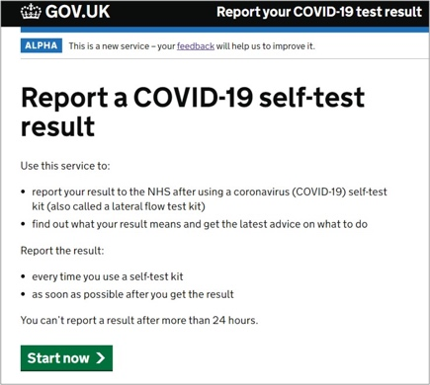
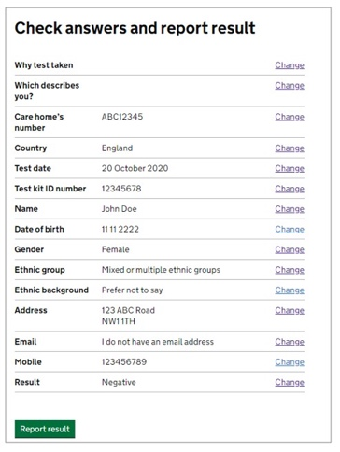
  - Date of birth

  - Gender

  - Ethnic group

  - Home address

  - Contact details, including mobile number and e-mail address

  - The barcode number of your test kit

  - Date and time of their test

  - Test result

Please make sure that if you are completing this form yourself that you complete it immediately after you receive your result (no later than one day after testing).

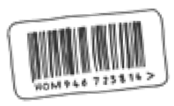
Before you start:
When you check in for your visit, you will receive four copies of a unique barcode. Hand one copy to the tester before you take your swab sample so they can track the test device to you.

You may remove your face mask to self-swab.

Self-swabbing instructions

The swabbing may feel uncomfortable. Do not insert the swab any deeper if you feel strong resistance or pain.
If there is blood or vomit on the swab sample, please alert a member of staff.

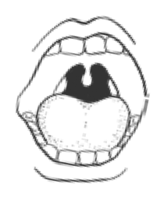
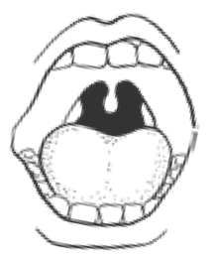
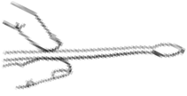
Using the mirror to help, look inside your mouth, and find your tonsils at the back of the throat. Your tonsils or where they would be (if they had
1

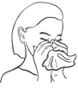
not been removed) are where you will swab your sample.
6

10
secs

Holding the swab in your hand, open your mouth wide and rub
the fabric tip of the swab over both tonsils (or where they would have
2

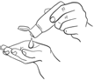
3

Handle
4

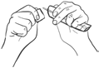
5
Gently blow your nose
into a tissue
Throw the used tissue into the clinical waste bin provided.
This is so that you get rid of excess mucus.

Use hand sanitiser to clean your hands.
This is so that you do not contaminate the test kit.

Soft tip
A member of staff
will hand you a packaged swab. Identify the soft, fabric tip of the swab.

Peel open the package from the handle-side of the swab and gently take it out.
This will be used for both throat and nose. Do not touch the soft tip of the swab.
Note: Do not touch your tongue, teeth, cheeks, gums, or any other surfaces with the fabric tip of the swab. The swab is invalid if it touches these parts, and you will need to get a new swab. If this happens ask a member of staff to get assistance.
been) at the back of the throat with good contact at least 3 times
(use a mirror to help you do this).
Carefully remove the swab stick from the back of your throat.

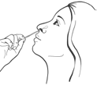
Put the same end of the same swab gently into one nostril until you feel a slight resistance (about 2.5cm or 1 inch up your nose).
7
10
secs
Roll the swab 5 times along the the inside of the nostril.

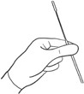
After collecting the sample hold the swab upright in your hand, do not put it down, and notify a staff member.
8
Be careful not to touch any surfaces with the swab.

You are ready to hand back your swab.
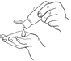
Please notify a member of staff and use hand sanitiser after handing in your sample. Put your face mask back on for the rest of your visit.

+

Need help?
If you have any questions or problems with this test kit, please call us. Helpdesk number 119.
Lines are open everyday, 7am to 11pm.

It is free of charge from any mobile or landline.

Thank you for supporting us.
13

